7th Grade Unit 1 Study Guide

______________________ (p 4) anything that has mass and takes up space. All matter is made up of atoms and molecules that are constantly moving.

An ________________ (p 57) is a pure substance that cannot be separated into simpler substances by physical or chemical means. The smallest particle that an element can be divided into and still be the same substance is an atom. Carbon, oxygen, gold, and iron are all elements.

An _____________ (p 83) is the smallest particle that an element can be divided into and still be the same substance.

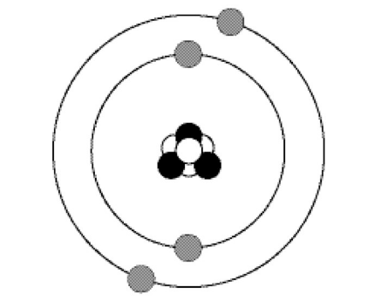

Atoms are made up of protons, neutrons and electrons
- protons have a positive charge and are found in the nucleus, or center of the atom
- neutrons are neutral (no charge) and are found in the nucleus
- electrons have a negative charge and are found in electron shells around the outside of the atom.

Label the parts of the atom below

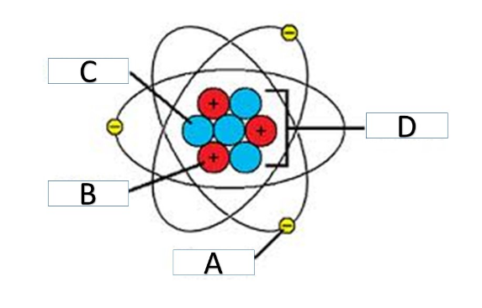
A__________________________________

B__________________________________

C__________________________________

D__________________________________

Elements are arranged in the ______________________________(p108) by the number of protons in their atoms. The atomic number of an element is equal to the number of protons in the atom. Most of the elements in the periodic table are metals. Other elements are non-metals or metalloids. As you move down the column in the periodic table, atomic mass increases.
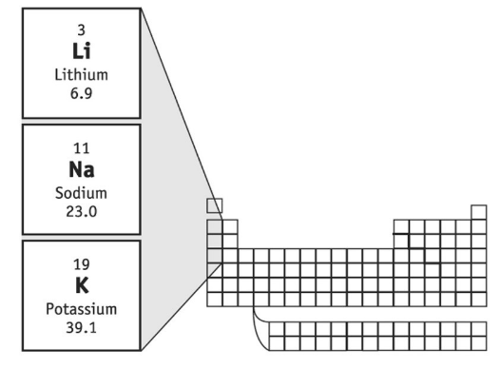

The _____________________ (page 93) of an atom is the number of protons + the number of neutrons. You can calculate the number of neutrons by subtracting the atomic number from the atomic mass.

What is the atomic mass of the atom shown below?_________________

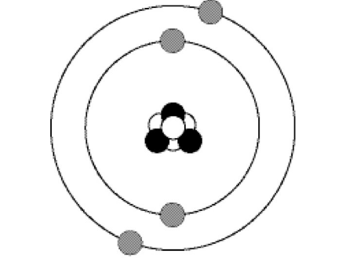

Molecules are 2 or more different elements that are chemically combined C02 or (carbon dioxide) is a molecule because it contains Carbon and Oxygen atoms. It contains 1 Carbon and 2 Oxygen atoms.
H20 (or water) is a molecule because it contains Hydrogen and Oxygen atoms. It contains 2 Hydrogen atoms and 1 Oxygen atom per molecule.

A ____________________(page 60) is a pure substance made up of 2 or more elements that are chemically combined. They are pure substances because they cannot be separated by physical methods. O2 is not a compound because it only contains only oxygen atoms.

When elements form mixtures, the elements keep their original properties.
Mixture is a combination of 2 or more substances that are not chemically combined. Sand is a mixture. To separate mixtures you need to know the physical properties of the components of the mixture.

Element examples
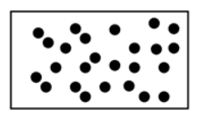
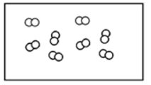

Compound examples
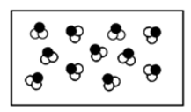
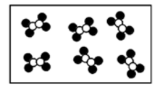

Homogenous mixture - you cannot see the different parts of a mixture

Heterogeneous mixture - you can see the different parts of the mixture

______________________ (p 14) a change in matter from one form to another without a chemical change (examples: cutting, evaporation, filter)

___________________(p 18) a change that occurs when one or more substances change into entirely new substances with different properties

What is the difference between an element and a compound?

____________________________________________________________

____________________________________________________________

____________________________________________________________

____________________________________________________________

____________________________________________________________

____________________________________________________________

What is the difference between a mixture and a compound?

____________________________________________________________

____________________________________________________________

____________________________________________________________

____________________________________________________________

Describe the difference between a chemical change and a physical change?

____________________________________________________________

____________________________________________________________

____________________________________________________________

____________________________________________________________

Provide an example of a chemical change.

____________________________________________________________

____________________________________________________________

____________________________________________________________

____________________________________________________________

Provide an example of a physical change.

___________________________________________________________

____________________________________________________________

____________________________________________________________

____________________________________________________________

